061006T4ICT
ICT Technician Level 6
ICT/CU/IT/CR/09/6/A
Perform Graphic Design
Nov. /Dec. 2022

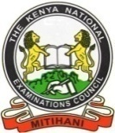
THE KENYA NATIONAL EXAMINATIONS COUNCIL

TIME: 2 HOURS

PRACTICAL ASSESSMENT
INSTRUCTIONS TO THE CANDIDATE
- You have 10 minutes to access the graphic design equipment and tools needed
- You have 2 hours to perform graphic design as provided in the task

This paper consists of THREE (3) printed pages
Candidates should check the question paper to ascertain that all the pages are printed as indicated and that no questions are missing.

You are provided with the following resources for the tasks:
- Computer
- Printer
- Printing papers
- Authoring graphic design software
- Scanner
- Camera
- Hardcopy of the Kenyan court of arms

TASK 1
Provided with the necessary graphic design equipment and tools, make a poster on “Anti-Corruption” with suitable graphics within a size of 5” x 7” with the colors as shown in the figure below and print out.
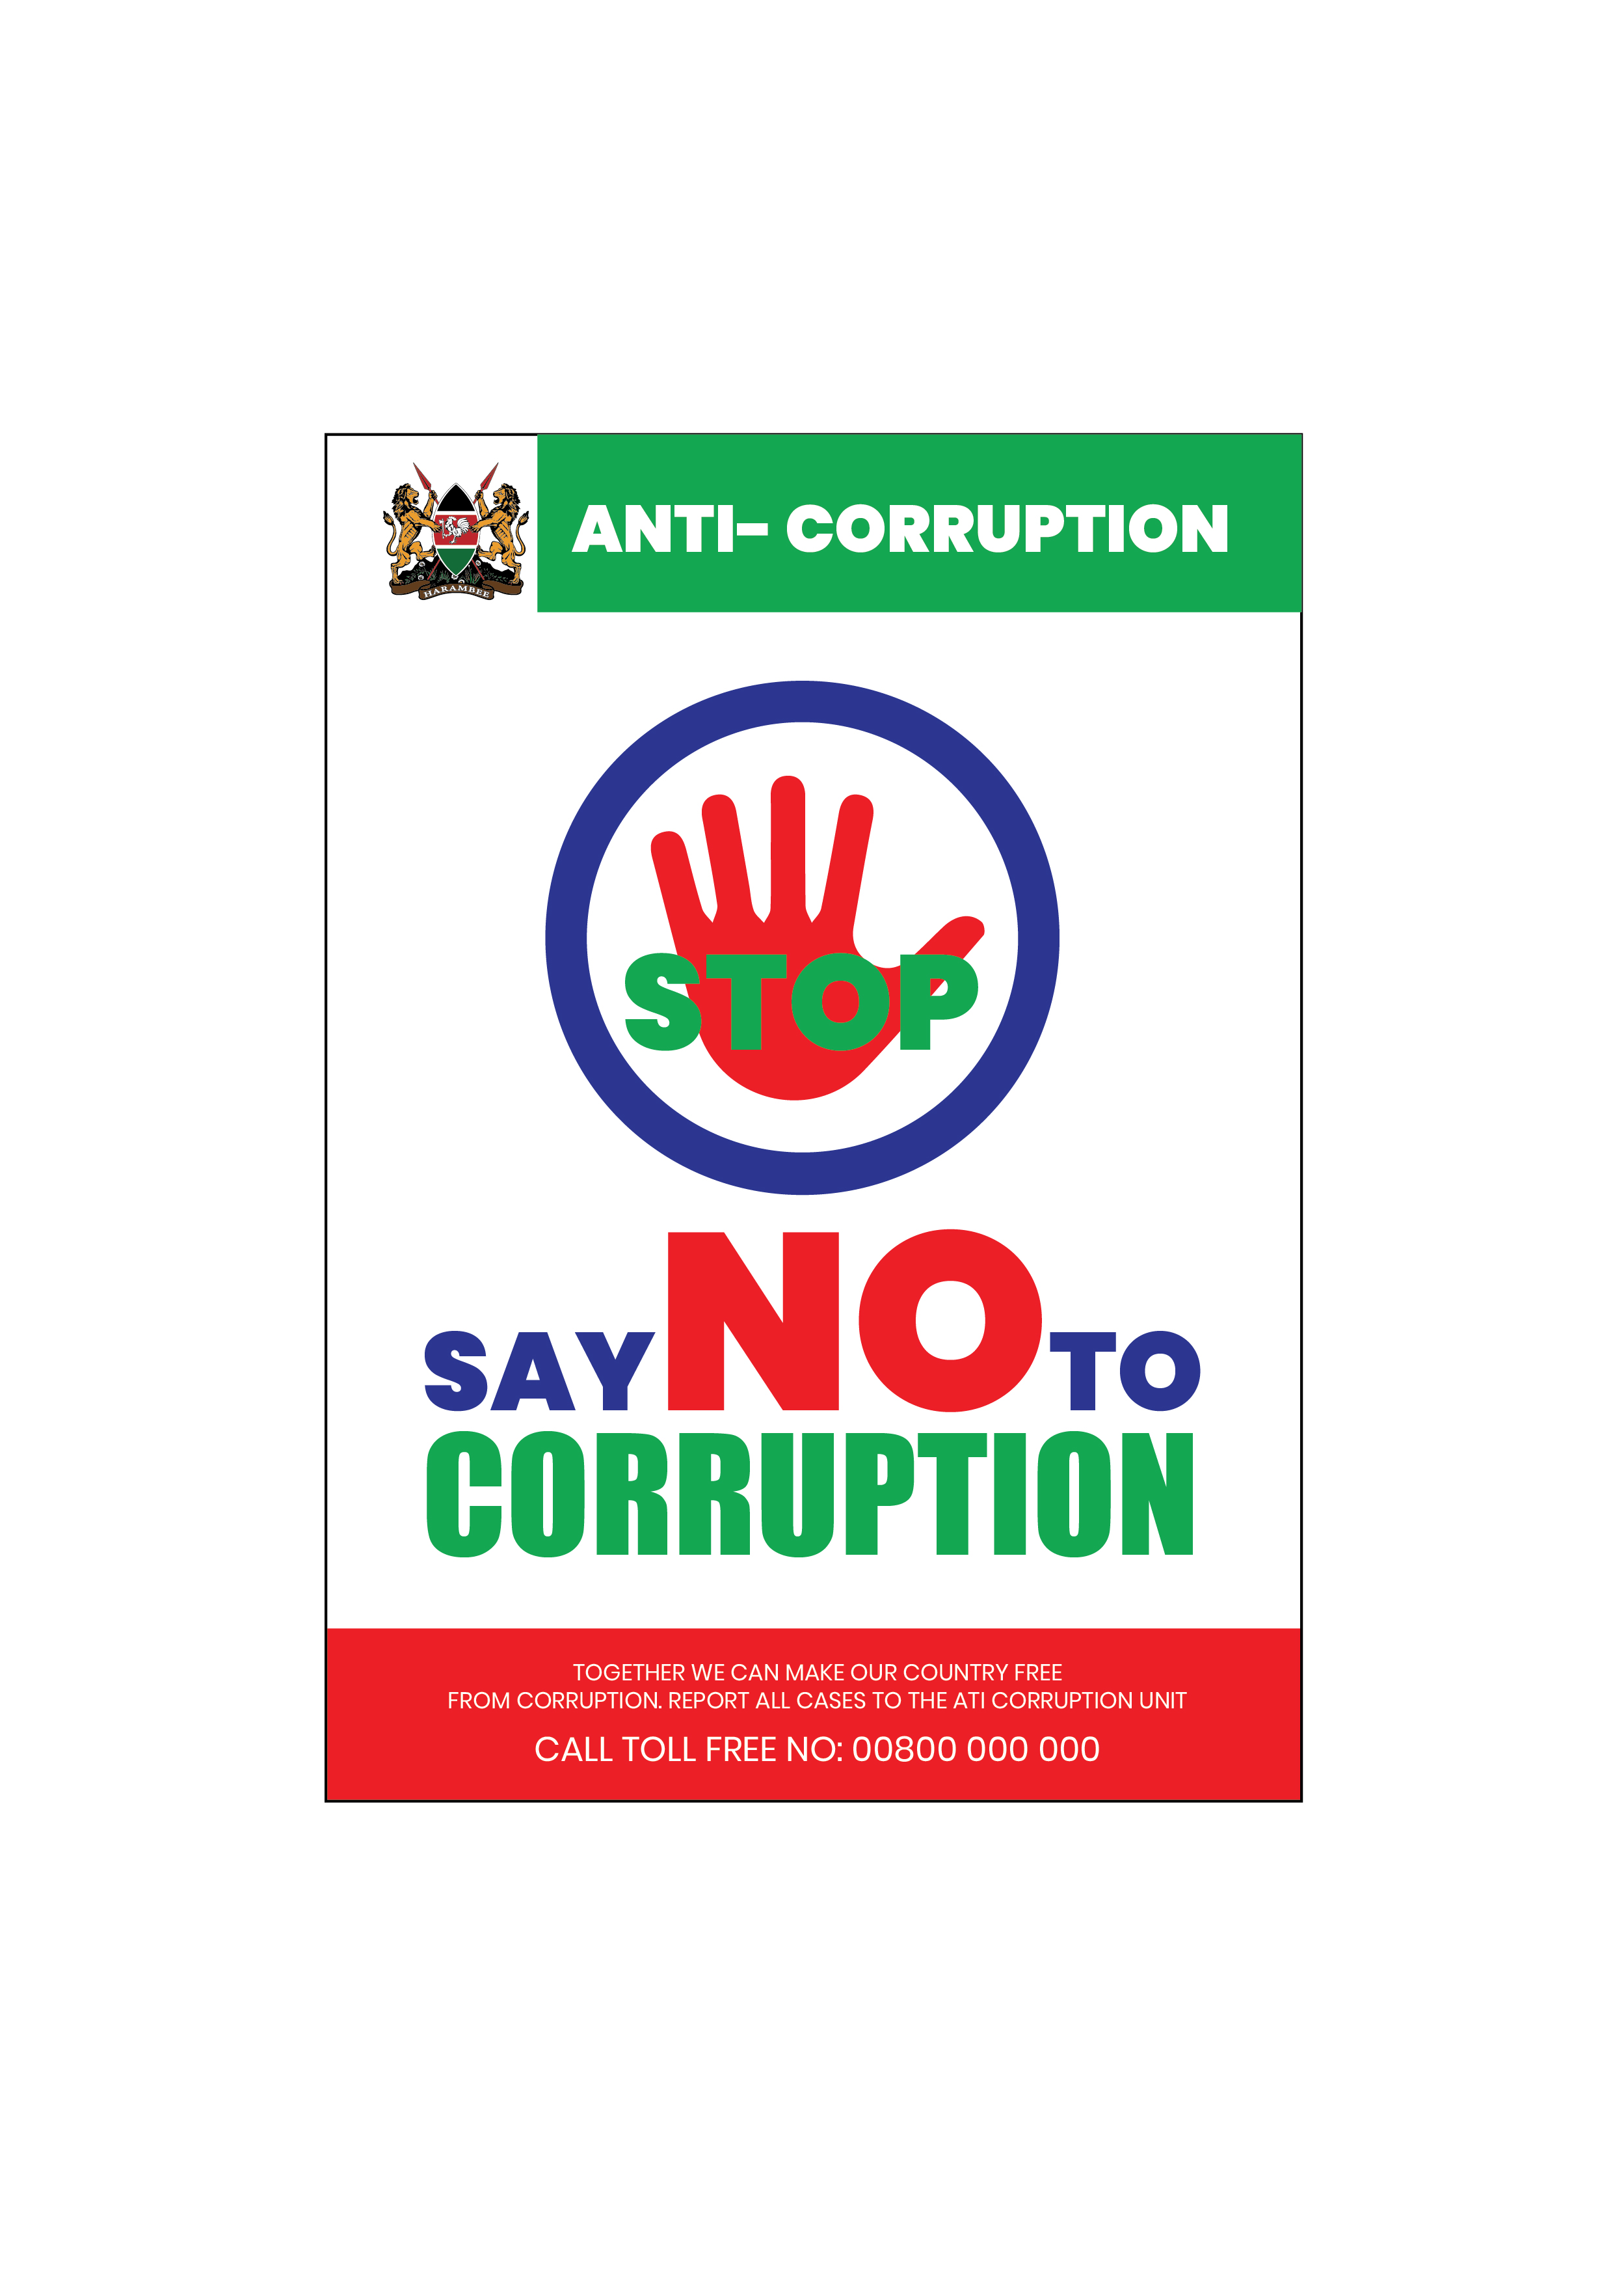

TASK 2
Design a visiting card, letter head and logo for ‘Oxford’ publishing house with the justification of design created as shown in the figure below and print out.

Use the following sizes:
Visiting card-2” X 3.5”
Letter head -4” X 6”
Note: Use 3 colors only.
Also describe the relevance of the logo.

